# Project Name: Blood Donation System

# Subsystem Name: Payment

# Partner’s Roll: 1605093

# 1605098

# 1605104

# 1605111

# 1605112

# 1605120

We decided to design this subsystem because if any blood donor agrees to donate based on a certain payment, then the receiver or the person who requested the blood has to send money to DONOR via third party system like Bikash or NAGAD .We thought it would be a great idea if our app had a payment sub system so that the transaction would be efficient and smooth and it will save a lot of time for the receiver and sender.

Now below there are four Diagrams, Use Case, Class, Data Flow and Sequence Diagram.

# USE CASE DIAGRAM

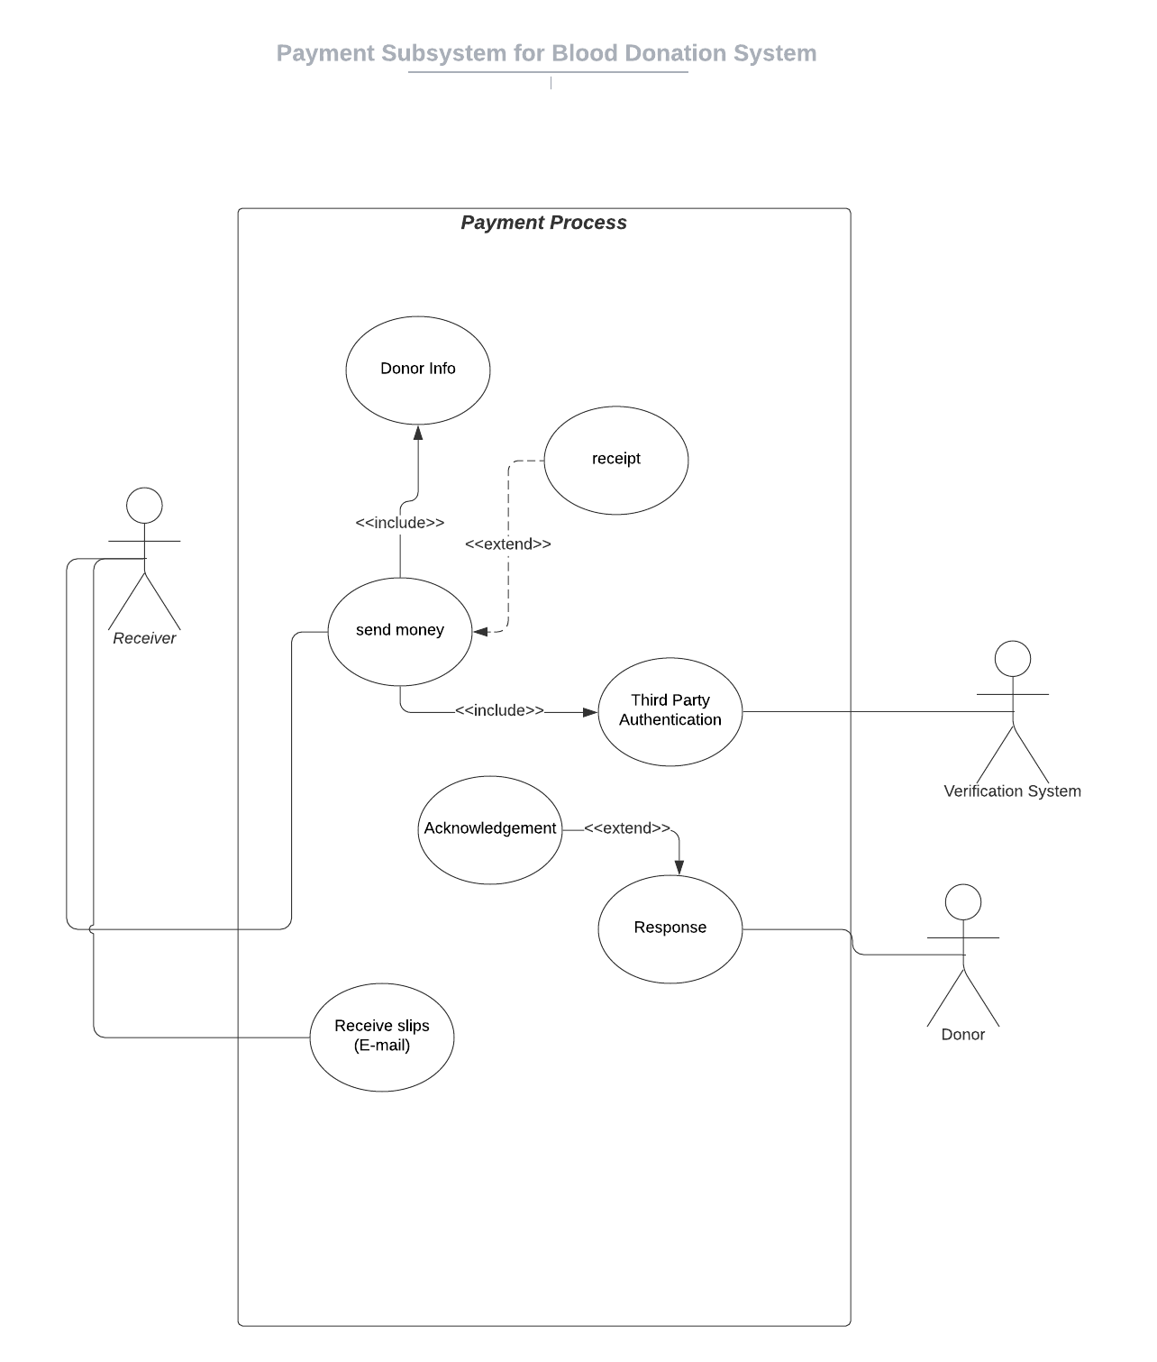

# Class Diagram

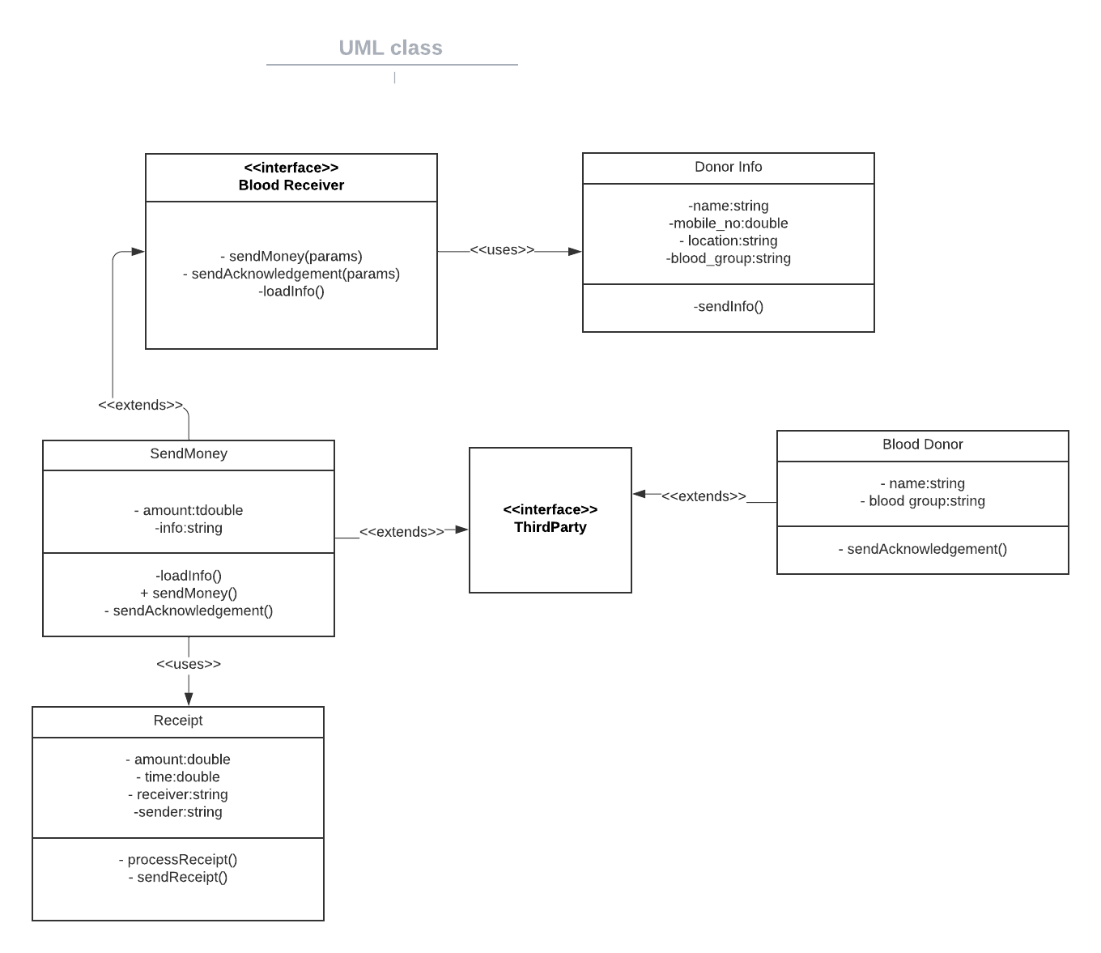

# Data Flow Diagram

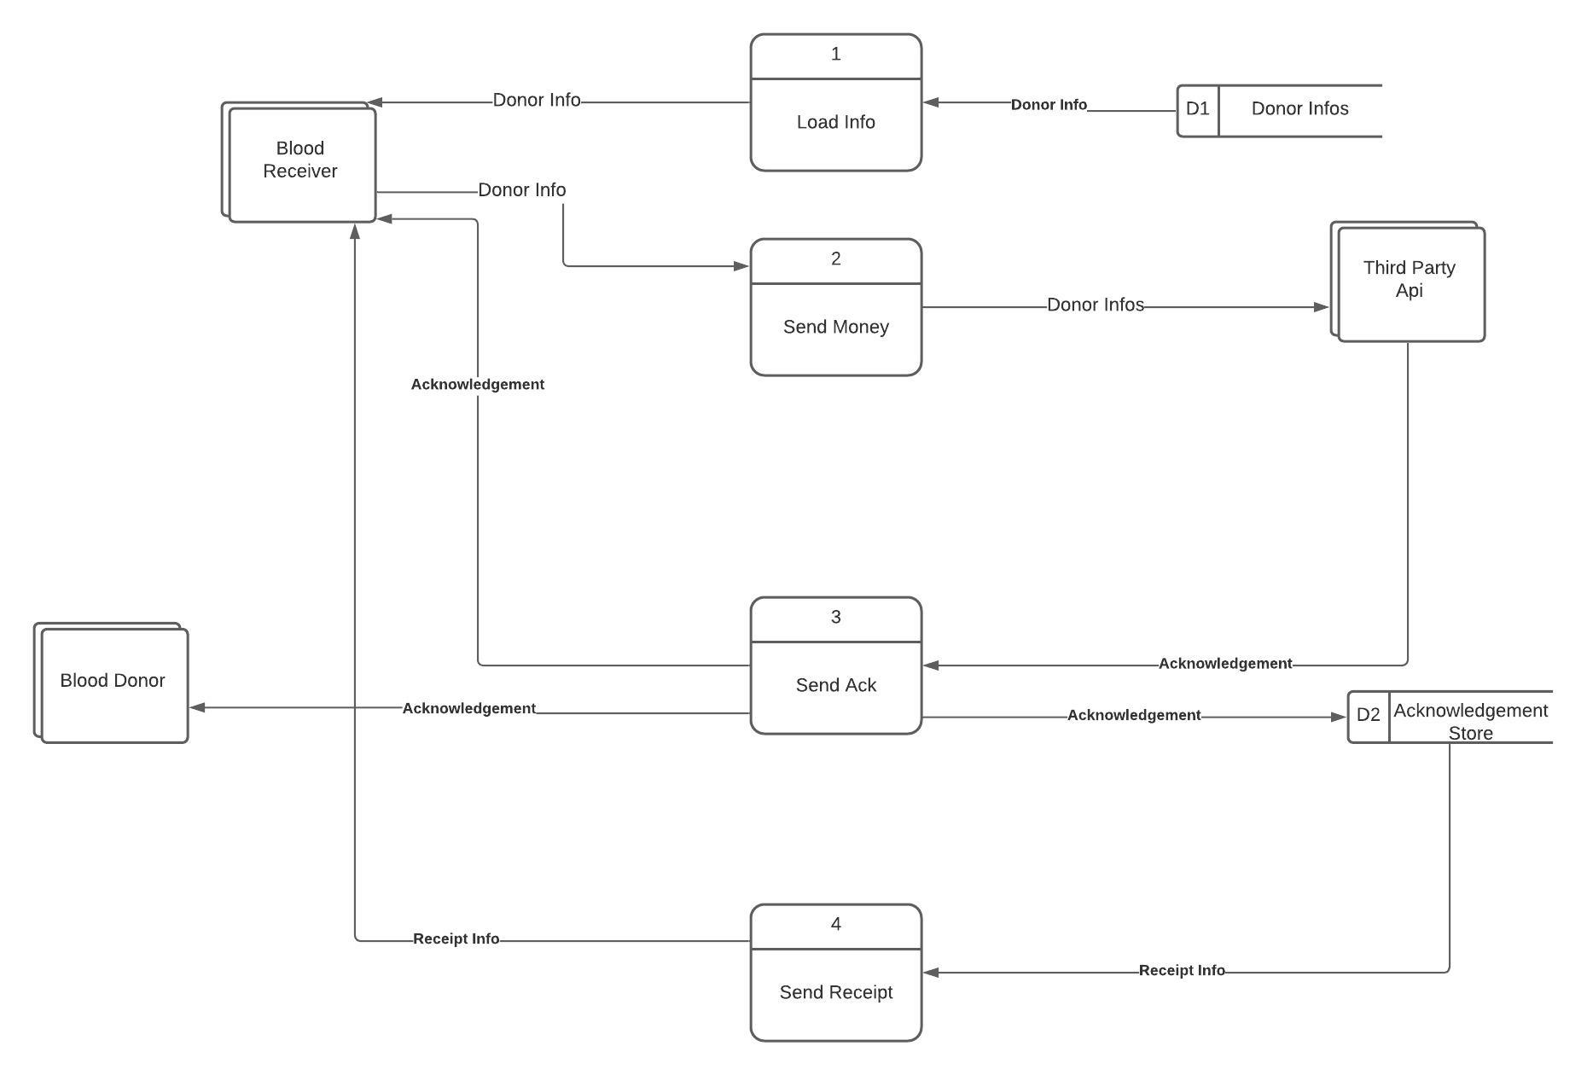

# Sequence Diagram

